Project Initialization and Planning Phase

Date | 28 January 2026
Team ID | LTVIP2026TMIDS66241
Project Name | Civil Engineering Insight Studio
Maximum Marks | 3 Marks

Define Problem Statements:
Therefore, the problem is to develop a centralized, intelligent, and user-friendly platform Civil Engineering Insight Studio that leverages data analytics and modern technologies to streamline project planning, improve accuracy, enhance decision-making, and optimize overall construction project performance.
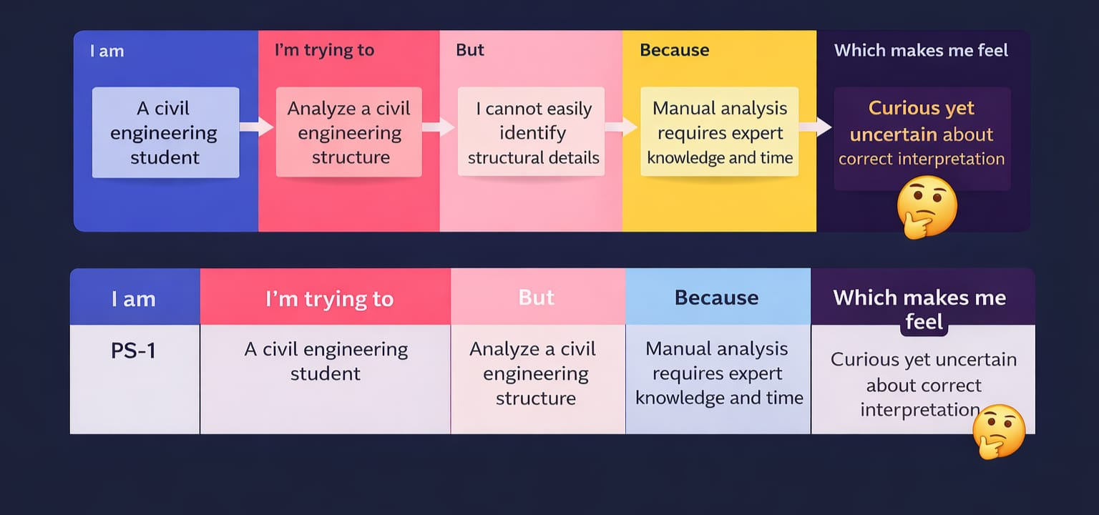

Problem  Statement  (PS) | I am | I’m trying to | But | Because | Which makes me feel
PS-1 | A civil Engineering Student | Analyze a civil engineering structure | I cannot easily identify structural details | Manual analysis requires expert knowledge and time | Curious yet uncertain about correct interpretation
PS-2 | A civil engineering student | Analyze a civil engineering student | Manual analysis requires expert knowledge and time | Manual analysis requires expert | Curious yet uncertain about correct interpretation

